Metropolitan State University, Saint Paul, Minnesota

ICS 140 Computational Thinking with Programming

Lab 7

**Introduction to For Loops**

For loops are count controlled loops designed to either run a block of code a predetermined number of times or iterate through a sequence of data and execute a block of code for each item in the sequence.

On line 3, we have an example of a for loop that executes a predetermined number of times.

On line 4, we have a similar 4 loop, but this time we use a target variable called number. When creating a for loop that iterates through an object, a target variable can reference the value for each loop. In this example, it would access 0,1,2,3, and 4.

On line 11, we have an example of iterating over a list of items where the target variable name will be used in the loop to print each name in the list.

When using target variables to iterate through a sequence, the target variable can be given any name. Whatever is listed between the “for” and “in” keywords will become a variable that can be accessed within the loop to reference the value.

**Warm Up Coding**

1. Using a for loop and a range function, write code that will count from 1 to 10 printing out the numbers.

for x in range(10):

print(x +1)

1. Using a for loop to iterate through the following sequence of numbers and for each one print it and indicate if it is odd or even.

numbers = [8,6,7,5,3,0,9]

for number in [8,6,7,5,3,0,9]:

if number % 2 == 0:

print(f'{number} is even')

else:

print(f'{number} is odd')

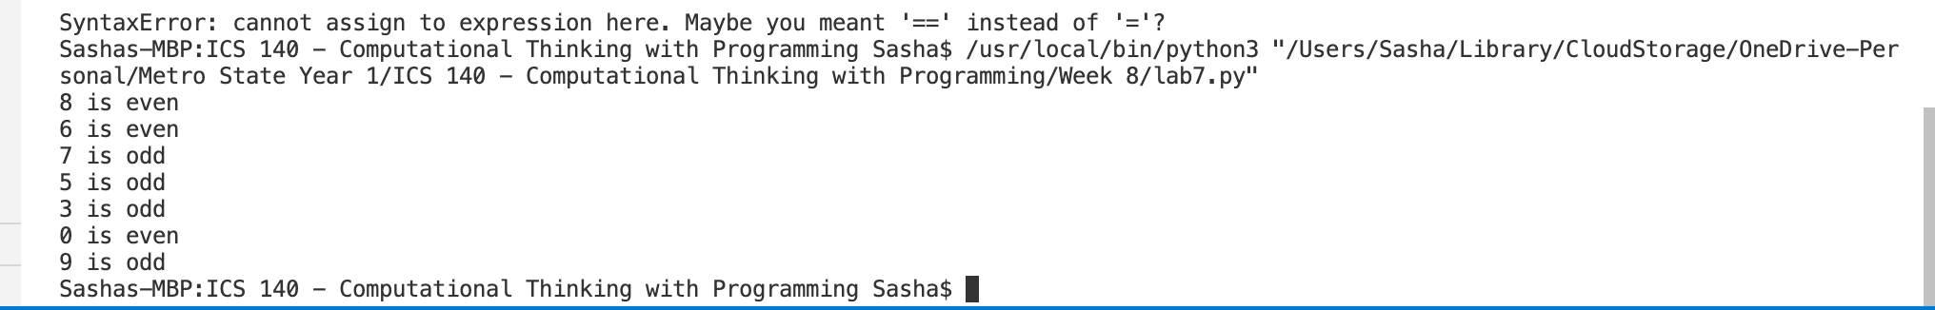

**Hypnotic Pattern**

Write a program that uses the turtle library to draw the following design.

Copy the python code in the section below.

**Python Code**

import turtle

al = turtle.Turtle()

x = 300

al.penup()

al.left(90)

al.forward(200)

al.right(90)

al.forward(200)

al.pendown()

for _ in range(15):

al.right(90)

al.forward(x)

al.right(90)

al.forward(x)

x = x-20

turtle.done()

Take a screenshot of the shape and paste it below.

**Example Drawing**

